**Event Management App**

**Source Code:**

https://github.com/kalviyarasi/AssistedProjects/tree/master/Phase4

**Write ups:**

* Event management app is designed using Angular Js.
* Admin can login using email and password.
* After successful login, admin can see the list of employees.
* Admin can
* add new employees,
* delete existing employee,
* edit the employee details.
* Admin can also change the password.
* Navigation bar is used to navigate from one field to another.
* Since angular is used, there will be no reloading and refreshing happens.
* With the use of CSS and bootstrap a well look single web page has been developed.

**Screenshots:**

**Admin login form where admin enters email and password.**

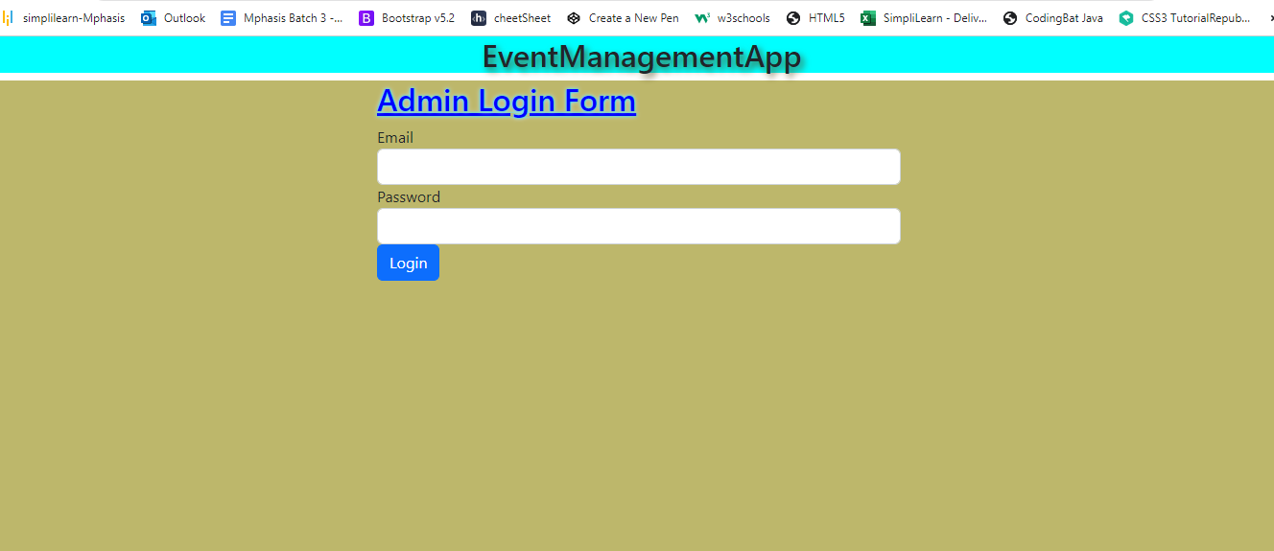

**Admin login credentials is defined in db.json file**.

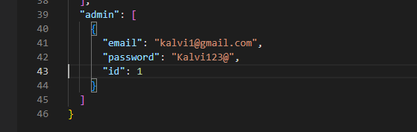

**If the credentials are true, then a pop up window which tells “Login success” is displayed**.

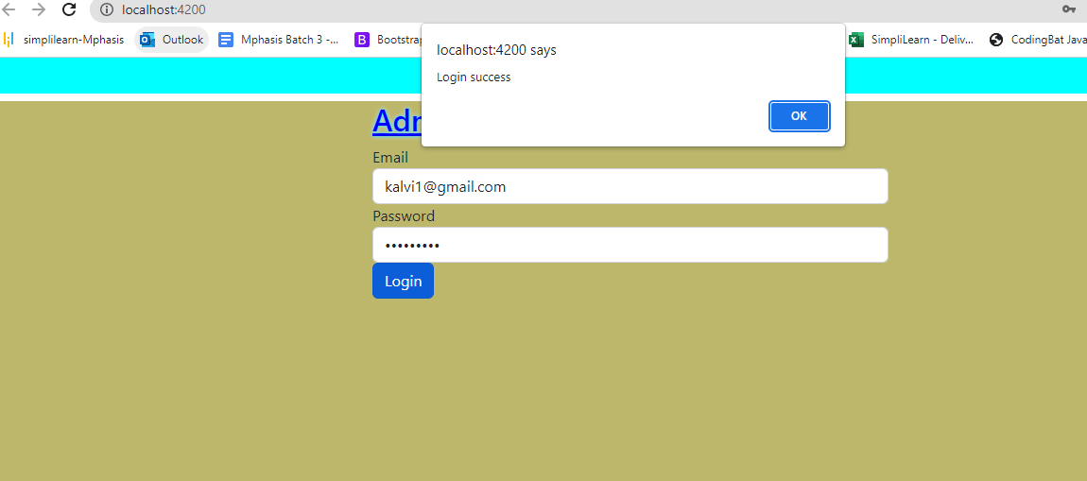

**If we click on ok it prompts to home page of event management app.**

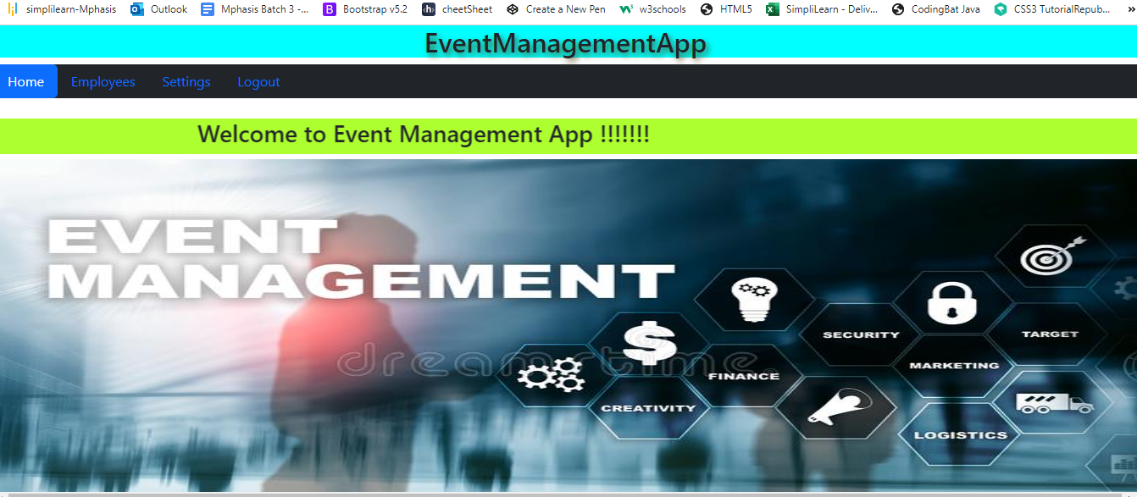

**Navigate to Employee, where admin can view list of employees.**

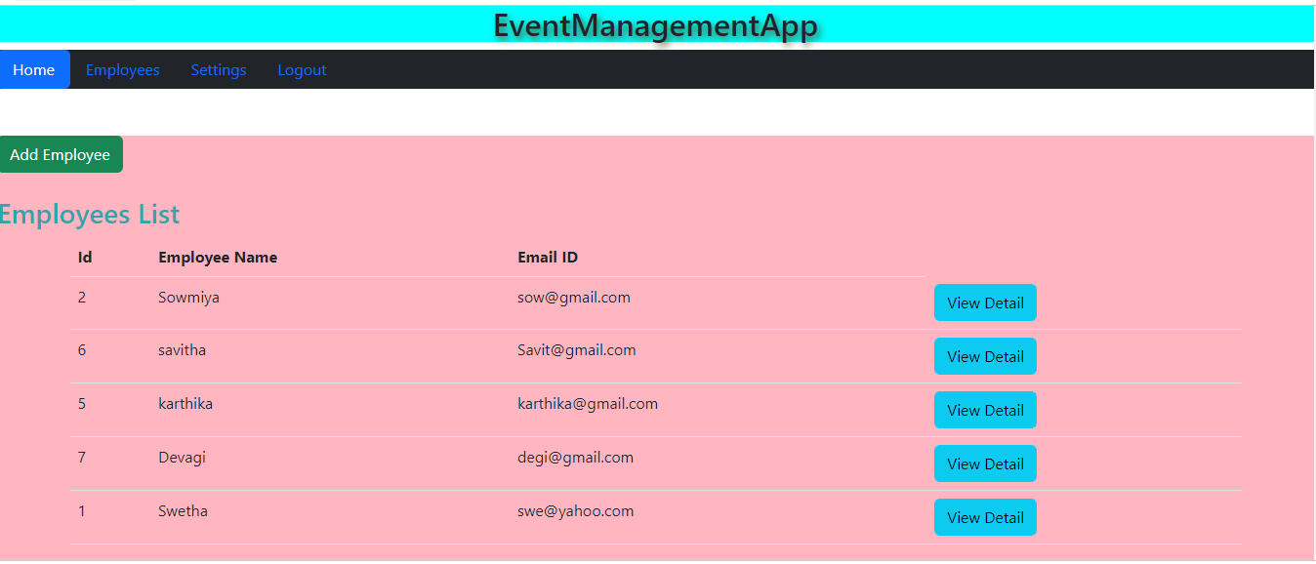

**Admin can add new employee details.**

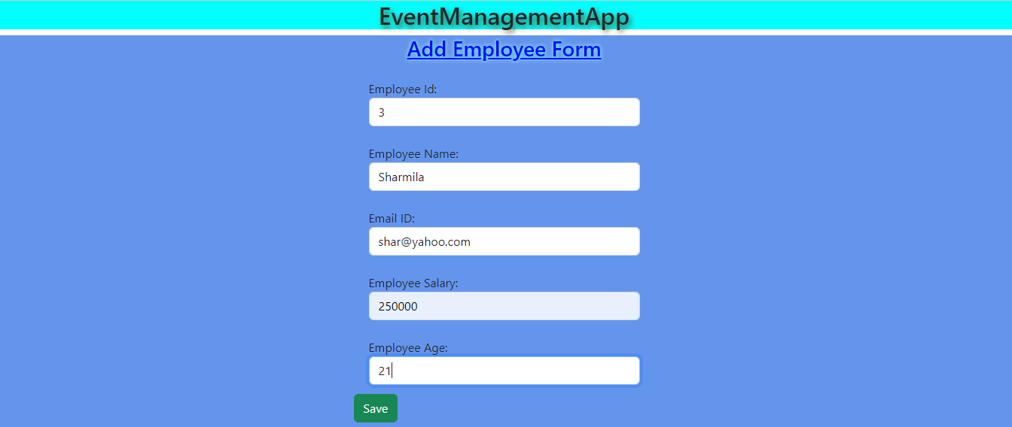



**The added employee list can be seen in the below page.**

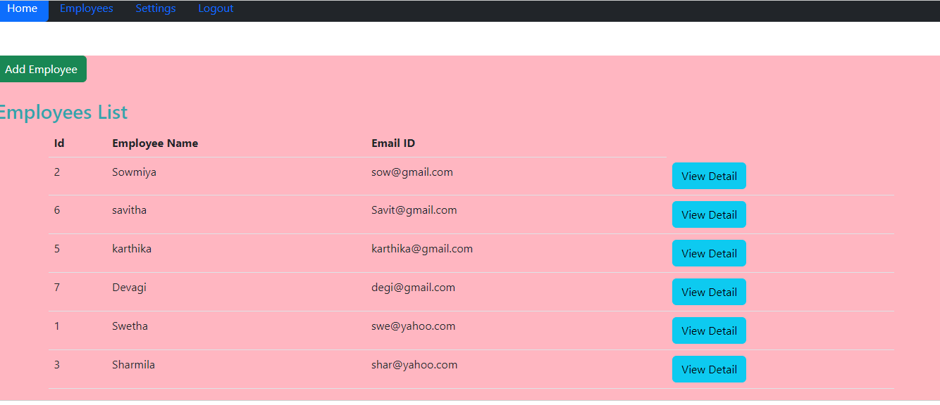

**Admin can edit the existing employee details by clicking on “edit” button.**

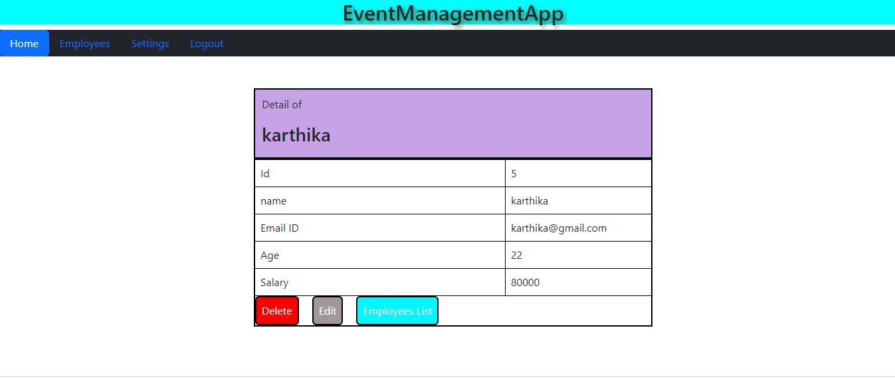

**Admin edit the employee details. Cannot alter employee id.**

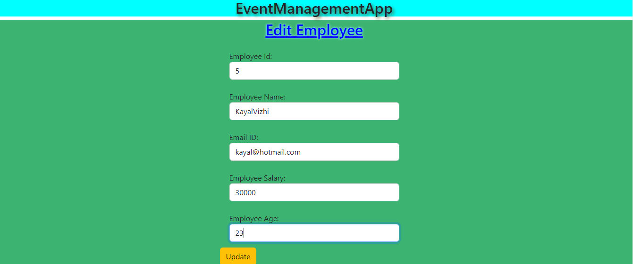



**We could see the edited employee details in the below page**.

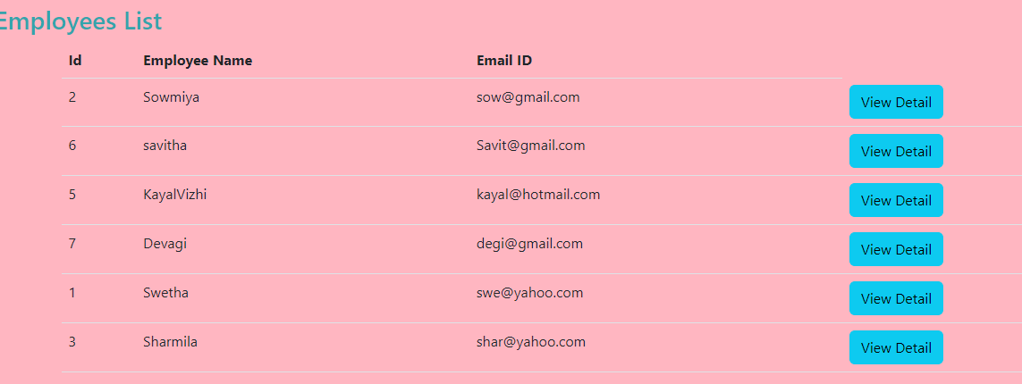

**Admin can delete the existing employee details.**

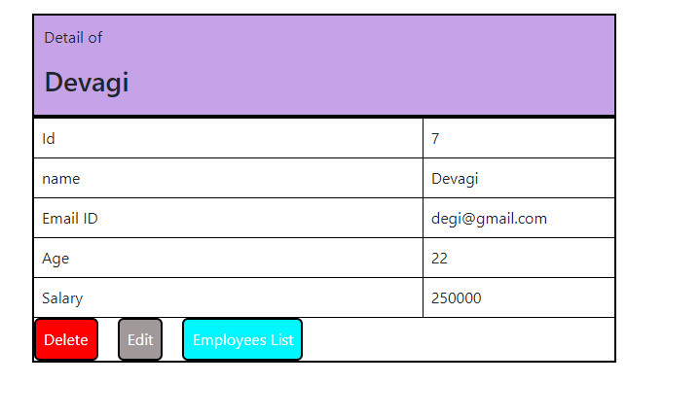

**The employee “devagi” details has been deleted.**

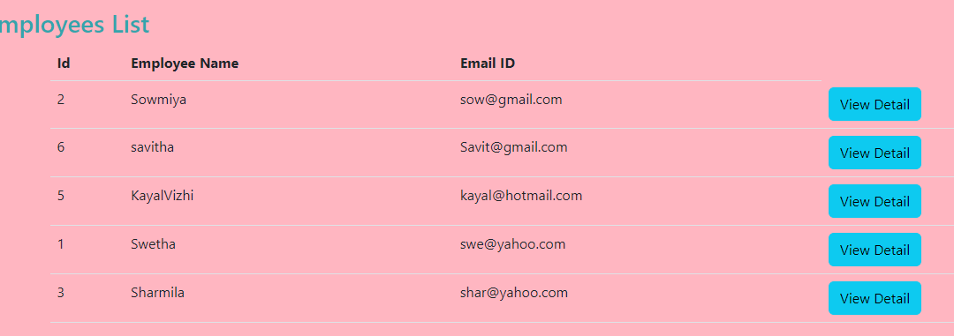

**Admin can the password.**



**After changing the password, admin is prompted to login.**

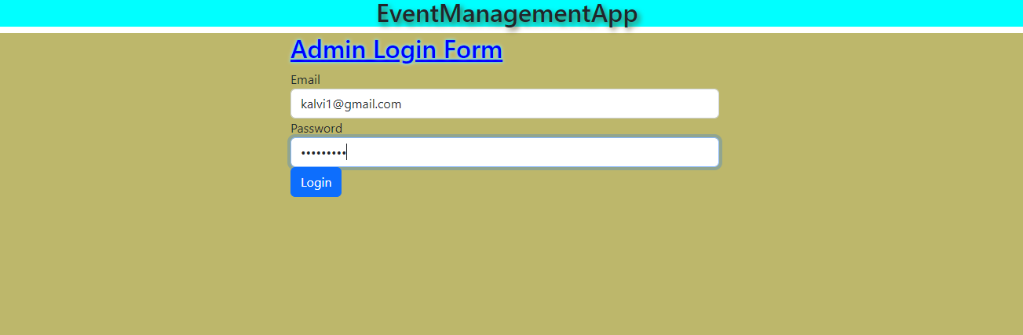

**If the login is successful, then a pop up window will be displayed indicating that login was successful.**

